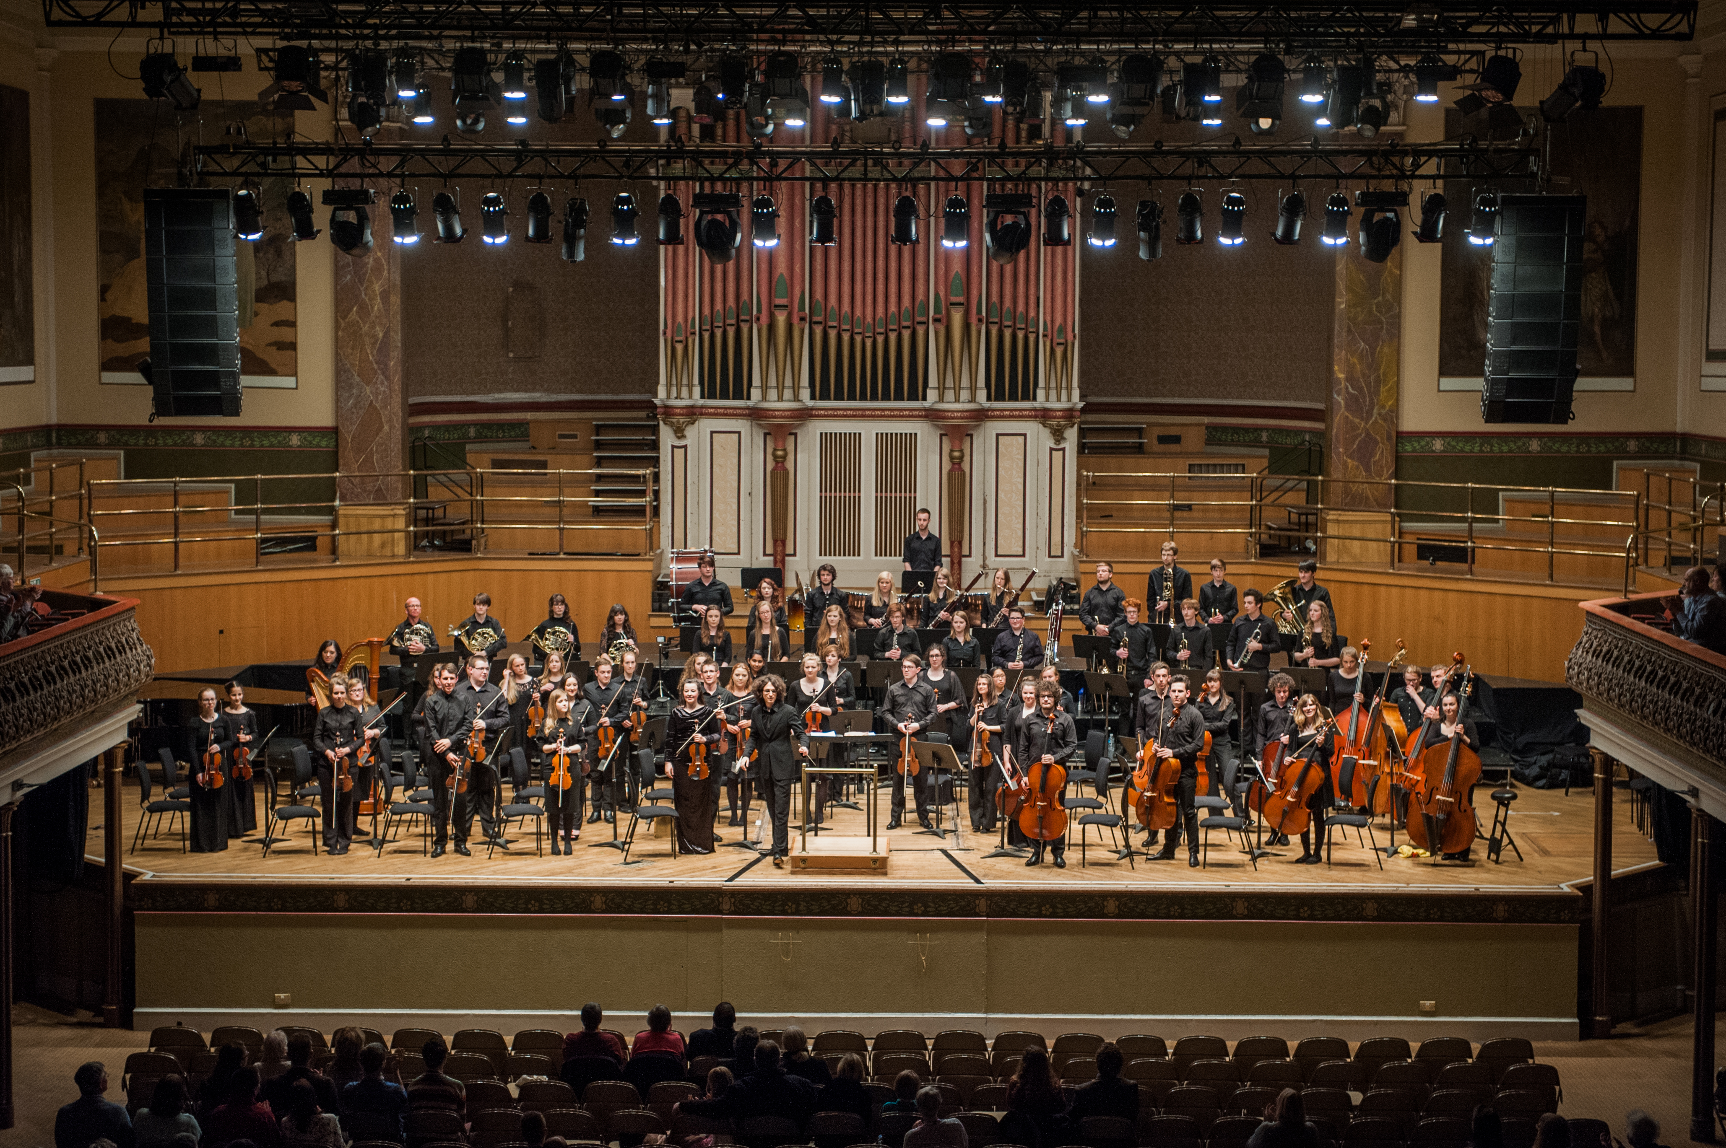

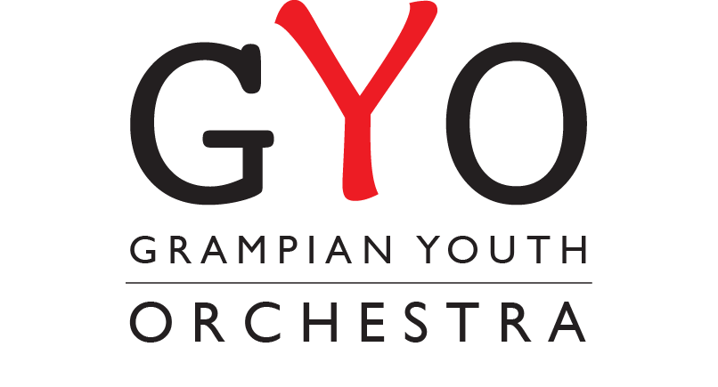
GRAMPIAN YOUTH ORCHESTRA
SUMMER COURSE 2015

Sunday 21st June 2015, 7.30 pm
Aberdeen Music Hall

The GYO 2015 Summer Course will take place from Thursday 18th June - Sunday 21st June, 2015.

There will be a pre-course rehearsal day on Sunday 26th April 2015, which all players should attend. The Conductor will be Chris Swaffer and the soloist will be Lauren Steel. The program for the 2015 course will be Festive Overture by Shostakovich, Cello Concerto in E minor by Elgar and Symphony No 9 “New World” by Dvorak.

Successful candidates must be available for all dates of the June course.

ELIGIBILITY - Players from anywhere in the North East of Scotland (born or studying in) between the ages of 12 and 22 (as of October 31st 2014 inclusive) are eligible. Players should be at ABRSM Grade 7/8 level but players working towards this level are encouraged to apply.

AUDITIONS - All applicants will be auditioned. Auditions will take place on the dates printed below. Please indicate which date you would prefer for audition on the application form.

Wednesday 12th November 2014 - 4 pm - 9 pm - North East of Scotland Music School, Huntly Street, Aberdeen.

Friday 14th November 2014 - 4 pm - 9 pm - North East of Scotland Music School, Huntly Street, Aberdeen.

Saturday 15th November 2014 - 9 am - 6 pm - North East of Scotland Music School, Huntly Street, Aberdeen.

Anyone not able to attend an audition on these dates will be requested to send a DVD recording.

FEE - There will be a non-refundable course fee of £80. More information will be sent regarding the course fee following the auditions.

* Please note this is a non - residential course

ORCHESTRAL COURSE TIMETABLE 2015

All the course rehearsals will be held within Hillview Community Church, Earlsend Road, Cults, Aberdeen.

Rehearsal day: Sunday 26th April - 9.00 am - 5.30 pm at Cults Academy, Aberdeen.

Thursday 18th June: 5.00 pm - 9.30 pm
Friday 19th June: 9.30 am - 9.30 pm
Saturday 20th June: 9.30 am - 9.30 pm
Sunday 21st June: 2 pm - 5.30 pm (Music Hall, Aberdeen)

Concert: Sunday 21st June, 7.30 pm, Aberdeen Music Hall.

Please return all completed forms to: grampianyouthorchestra@hotmail.com

*Please do not send any paper forms.

GRAMPIAN YOUTH ORCHESTRA SUMMER COURSE 2015
APPLICATION FORM

Please fill in and return this form no later than Friday 17th October 2014.

TO BE COMPLETED BY ALL APPLICANTS

Surname _________________________ Forename (s) _________________________________

Home Address (in full) __________________________________________________________

_____________________________________________________________________________

____________________________ Post Code _______________________________________

Telephone No _____________________________ Mobile ____________________________

Email address _________________________________________________________________

Date of Birth_______________________ Age (as of Oct 2013) ________________________

Term time address if different from above __________________________________________

____________________________________________________________________________

__________________________________ Post Code ________________________________

Name of Educational Institute (School, University etc)_________________________________

Telephone No (if different to above) ______________________________________________

Instrument __________________________________________________________________

How long have you been learning ________________________________________________

Name of present teacher _______________________________________________________

Last examination passed (if any) _________________________________________________

Current working level __________________________________________________________

2nd/3rd instruments and grades passed (if any) _____________________________________

Orchestral/Ensemble Experience _________________________________________________

____________________________________________________________________________

Please select your preferred audition date below. You can tick more than one box.

Wednesday 12th November - 4 pm - 9 pm - North East of Scotland Music School, Huntly Street, Aberdeen.
Friday 14th November - 4 pm - 9 pm - North East of Scotland Music School, Huntly Street, Aberdeen.
Saturday 15th November - 9 am - 6 pm - North East of Scotland Music School, Huntly Street, Aberdeen.

