sound is a new music organisation based in North East Scotland that runs the soundfestival, Scotland’s festival of new music, which takes place annually in October/November. It aims to make new music more accessible to audiences of all ages and backgrounds by presenting an eclectic range of music through a wide variety of events including concerts, talks, installations and workshops.

sound 2018 gratefully acknowledges the support of:
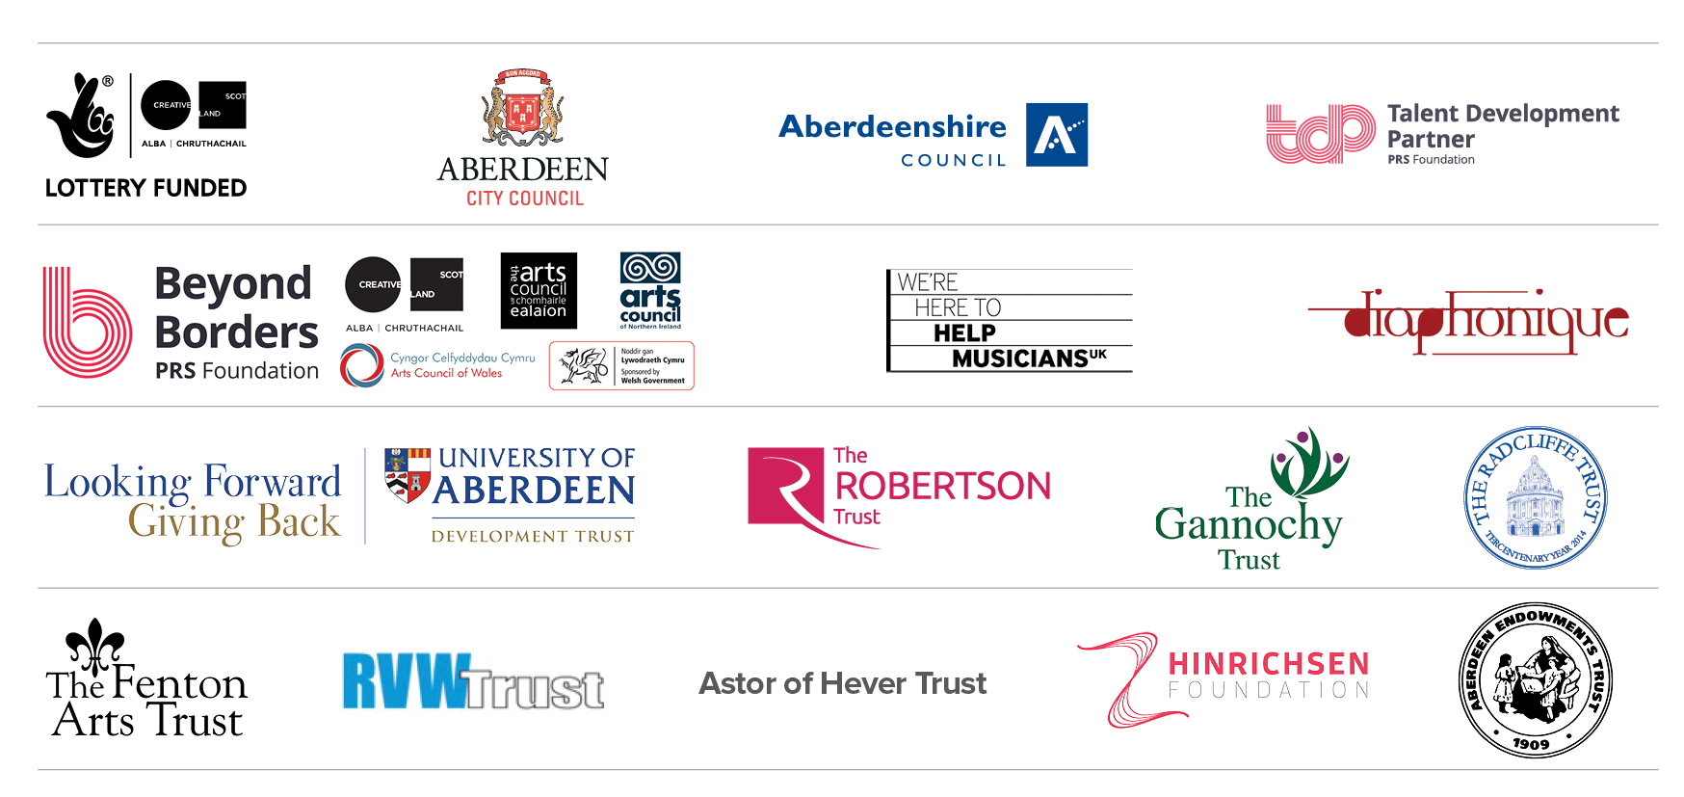

Join our mailing list and follow us on social media for regular updates!
www.sound-scotland.co.uk

 soundscotland  @soundfestival
 @soundscotland #soundfest18

sound, c/o the Barn, Banchory AB31 5QA
Tel: 01330 826526│email: info@sound-scotland.co.uk│web: www.sound-scotland.co.uk
Registered Company Limited by Guarantee No.394992, and Scottish Charity No. SC 037310
Patrons: Dame Evelyn Glennie DBE, Sir James MacMillan CBE and Rohan de Saram


Come and join us for

A Viola Day with Garth Knox

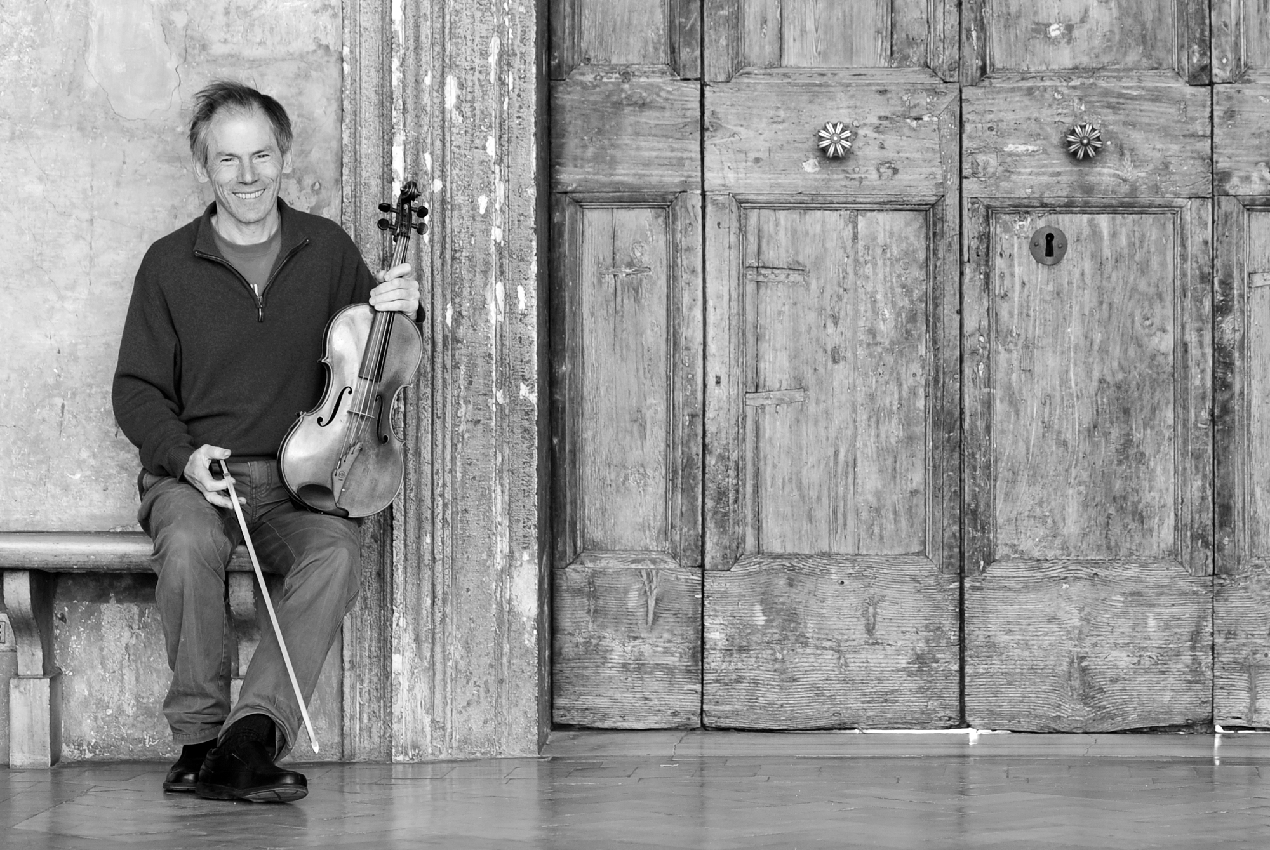

Sunday 28th October 2018
10am – 4.30pm

A workshop for viola players with Garth Knox
including an informal sharing session at 4pm

A Viola Day with Garth Knox

When: Sunday 28th October 2018 10am – 4.30pm with an informal sharing at 4pm

Where: Phoenix Centre, Newton Dee Village, Bieldside, Aberdeen, AB15 9DX

What: Under the expert guidance of Garth Knox, viola players are invited to take part in a multi-viola ensemble. The works to be rehearsed and performed in an informal sharing will include Garth Knox’s Not Giants but Windmills, John Cage’s Dream for five viola parts and a new work commissioned from our composer-in-residence Ailie Robertson. There will be an informal performance at 4pm.

Participants: Viola players of all ages and standards (beginners are welcome too). Whether you’re a virtuoso or can only play open strings, you’ll find a part for you in this relaxed day amongst fellow violists free from viola jokes!

Practical details: It is free to take part. Please bring your own sandwiches!

Garth Knox
Aberdeen-raised viola player and composer, Garth Knox, is at the forefront of the new music scene in many fields. He has become a unique performer of music of many different styles, ranging from minimalist understatement to the cutting edge of new techniques and new technologies.
Garth has always felt at home as an improviser, and now more and more so as a composer also, deploying his musical ideas as innovative instrumental theatre.

APPLICATION FORM

A Viola Day with Garth Knox

Name: _______________________________________

Address: _______________________________________

_______________________________________

_______________________________________

Telephone: _______________________________________

Email: _______________________________________

I would like to take part in A Viola Day with Gath Knox ◻

Standard (please state grade level if appropriate or if you’re a beginner):_________________________________________

Age (if under 18):____________________________________

PLEASE REPLY BEFORE THE 19th OCTOBER 2018 to:
sound c/o The Barn, Banchory AB31 5QA or email admin@sound-scotland.co.uk

In the second year of a five-year focus on 'endangered' instruments soundfestival shines a spotlight on the viola. There will be a number of performances and exhibitions throughout the festival. For more information, please visit our website: www.sound-scotland.co.uk

